**EVALUATION QUESTION-- Design automatic led Diwali lights (consisting of 6 led’s) such that it only works during night and can generate two patterns which can be toggled with switch. a. Pattern 1 – led blinks with a freq. of 500 msec. b. Pattern 2 – led blinks with a freq. of 1 sec.**

**CIRCUIT DIAGRAM-**

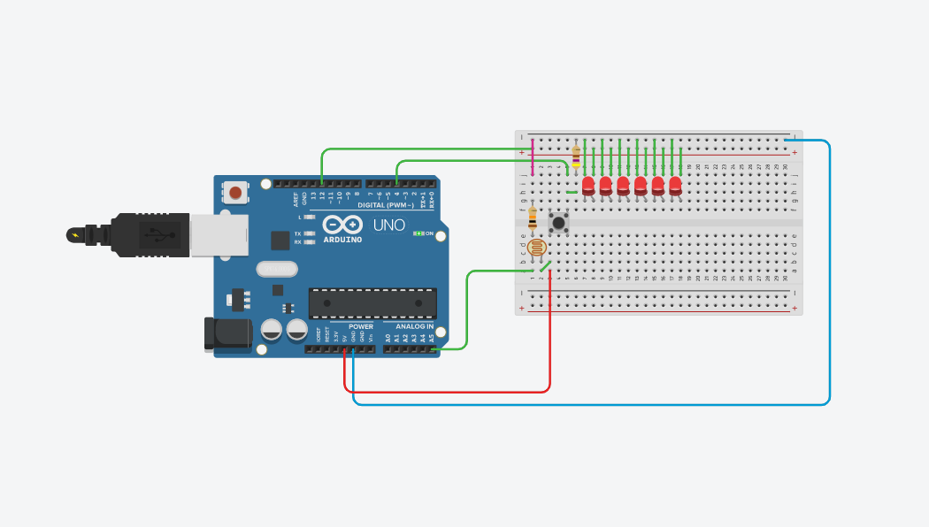

**CONCEPT USED-** USAGE OF SWITCH, PHOTORESISTOR.

**LEARNING AND OBSERVATION-** WE CAN EASILY MANUPLATE SIMPLE CONCEPTS INTO SOMETHING THAT IS BOTH PROFITABLE IF SOLD AS A PRODUCT AND SIMPLE COMPONENTS CAN RESULT INTO SOMETHING WONDERFUL IF COMBINED WITH A GOOD CODE.

**CODE-**

